This program was designed to analyze daily grocery purchase data for the Corner Grocer. The goal of the program is to read an input file containing items purchased throughout the day, calculate how often each item appears, and display that information in multiple formats. The program also creates a backup data file at startup to store the frequency results for later use.
To organize the code clearly, I created a class called GroceryTracker. This class contains both public and private sections, which improves structure and readability. The private section stores the input file name, backup file name, and a map<string, int> that holds item frequencies. I chose to use a map because it allows each grocery item (the key) to be paired directly with a numeric count (the value). This makes counting efficient and keeps the code clean.
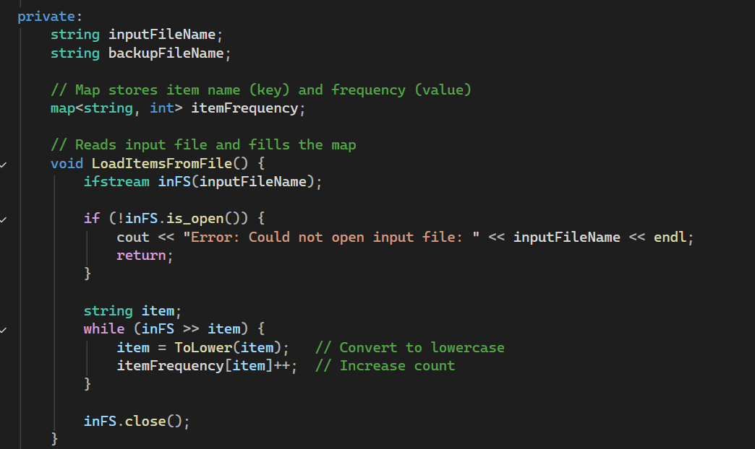
When the program starts, the constructor automatically reads the file CS210_Project_Three_Input_File.txt. As each word is read, it is converted to lowercase to prevent duplicate counts caused by capitalization differences (for example, “Apple” vs. “apple”). The map automatically increments the count for each item. After reading the file, the program immediately creates a backup file named frequency.dat. This file contains each item and its frequency and serves as a stored version of the processed data.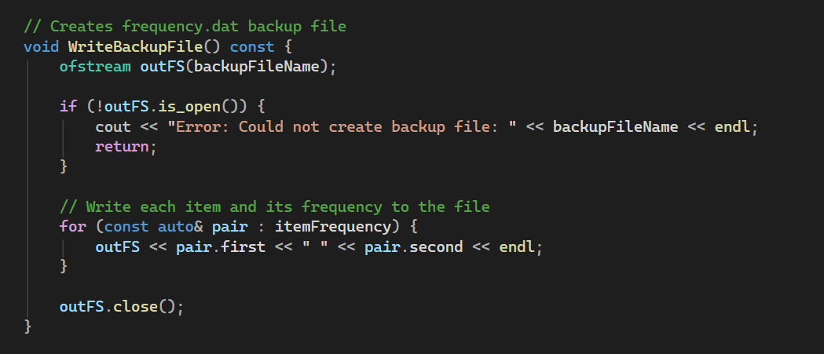
The program includes a user menu with four options. The first option allows the user to search for a specific item and returns how many times it was purchased. The second option prints all items along with their numeric frequencies. The third option displays the same data in the form of a histogram using asterisks to visually represent the quantity of each item. The fourth option safely exits the program.
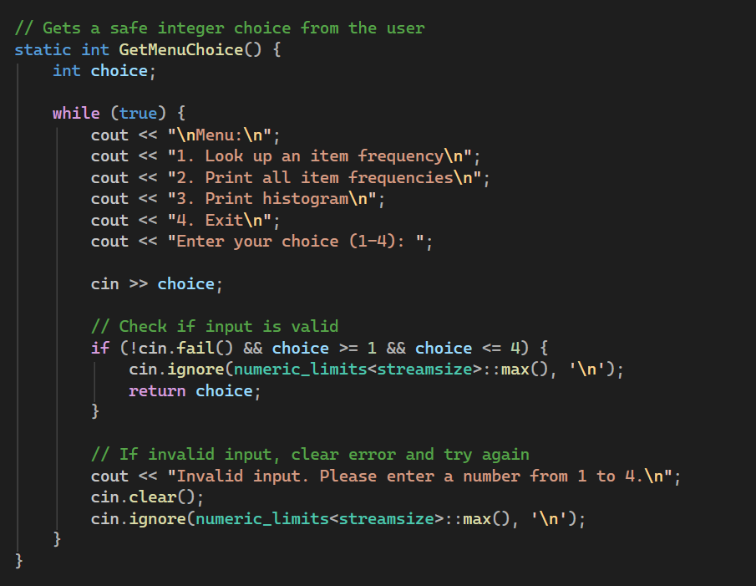
Input validation was added to prevent the program from crashing if the user enters invalid data. The menu function checks for incorrect input and clears the input stream before prompting again. This improves reliability and demonstrates good programming practice.
Overall, this program demonstrates the use of file input/output, maps for data storage, object-oriented design, input validation, and clear commenting. The structure keeps responsibilities separated within the class while maintaining readable and maintainable code. The design ensures the program runs efficiently while meeting all project requirements.

